**Nurdle Fact Sheet**

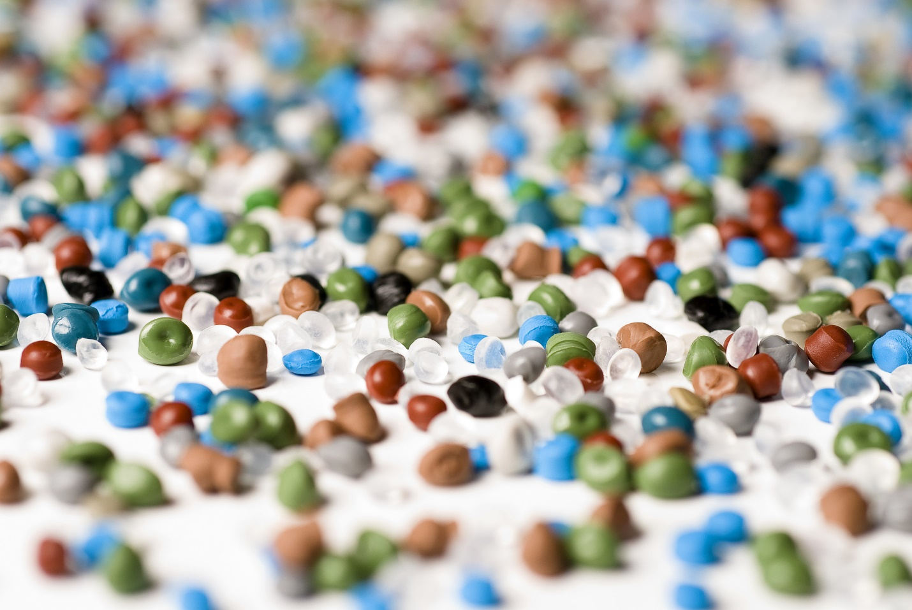

**What Are Nurdles?**

* Tiny plastic pellets, the building blocks of most plastic products.
* Billions are made each year—but many spill into rivers, railroads, beaches, and oceans.

**The Problem**

* Nurdles have polluted the environment since the 1950s.
* They spill at every stage: production ➝ shipping ➝ storage.
* Wildlife can mistake nurdles for food.
* Current prevention programs are **voluntary** and only a few companies participate.

**Awareness & Action**

* **Nurdle Patrol** collects data through citizen scientists.
* National media coverage and the **Texas Plastic Pollution Symposium** raise awareness and drive collaboration.
* Research helps us understand nurdle impacts and pushes for stronger solutions.

**What YOU Can Do**

👀**Spot it** – Look for nurdles on beaches, rivers, and railroads.  
📝 **Record it** – Log your findings at [nurdlepatrol.org](https://nurdlepatrol.org).  
🤝 **Share it** – Invite friends, family, or classmates to survey with you.  
🌍 **Change it** – Your data helps improve industry practices and shape new laws.

**Every nurdle counted is a step toward cleaner oceans.**